LETTERKENNY INSTITUTE OF TECHNOLOGY

ASSIGNMENT COVER SHEET

**Lecturer’s Name:**  Ruth Lennon

**Assessment Title:**  Lab 1: Centos Installation

**Work to be submitted to:**  Ruth Lennon

**Date for submission of work:**  1st January 2015

**Place and time for submitting work:**  RM 2294 9:30 am

To be completed by the Student

**Student’s Name:**  John ORaw

**Class:**  B.Sc. in Applied Computing

**Subject/Module:**  Server Administration

**Word Count (where applicable):**  N/A

**I confirm that the work submitted has been produced solely through my own efforts.**

**Student’s signature:**  **Date:**  1/7/2015

|  |
| --- |
| **Notes**  **Penalties:** The total marks available for an assessment is reduced by 15% for work submitted up to one week late. The total marks available are reduced by 30% for work up to two weeks late. Assessment work received more than two weeks late will receive a mark of zero. [Incidents of alleged plagiarism and cheating are dealt with in accordance with the Institute’s Assessment Regulations.]  **Plagiarism:** Presenting the ideas etc. of someone else without proper acknowledgement (see section L1 paragraph 8).  **Cheating:** The use of unauthorised material in a test, exam etc., unauthorised access to test matter, unauthorised collusion, dishonest behaviour in respect of assessments, and deliberate plagiarism (see section L1 paragraph 8).  **Continuous Assessment:** For students repeating an examination, marks awarded for continuous assessment, shall normally be carried forward from the original examination to the repeat examination. |
|  |

# Aims/Description

The aim of the lab is to install maven and create a java project with maven artifacts

# Method

1. Web documentation relating to CentOS was reviewed [[1]], [[2]], [[3]].
2. The relevant VMWare Workstation user manual was reviewed in detail [[4]].
3. A copy of CentOS was downloaded from the local mirror at ftp://ftp.heanet.ie. The path used was ftp://ftp.heanet.ie/mirrors/centos/6.5/isos/
4. The image downloaded in this case was CentOS-6.5-i386-minimum.iso
5. VMWare Workstation was run.
6. The preferences where changed to point to the E:\ drive to ensure that the virtual machine to be created would be completely stored on the external hard drive.
7. First attempts at installation failed as the Wizard in WS10 assumes a full install DVD, not the minimum image. The installation was carried out a second time using the option “I will install the operating system later” during the initial dialog, step 4.
8. The VM was named “VM-CO65-Gold” as this virtual machine was created as a clean installation which could be cloned as required. Defaults were used for all other settings.

The VM was booted up and login was successful.

1. The system was snapshotted at this point prior to software installation and updates, as per [[5]], section “Taking Snapshots of Virtual Machines”.
2. Guest additions were installed as per [[6]]
3. Updates were installed as per [[7]]
4. The system was cloned as per [5], section “Cloning Virtual Machines”.

# Results

Mvninit.bat was created to automate the recurring task of setting up the working environment of maven.  
mvninit.bat:  
set PATH=%PATH%;"X:\CEA\rootproject\labs\lab1-maven\Lab1\apache-maven-3.3.9\bin"  
set JAVA_HOME=C:\Program Files (x86)\Java\jre1.8.0_73

Mvnsetup.bat was created to ease setup of new projects.  
Using the command line parameters are used for setting up the Base directory, the new application directory and the Main class for the created project.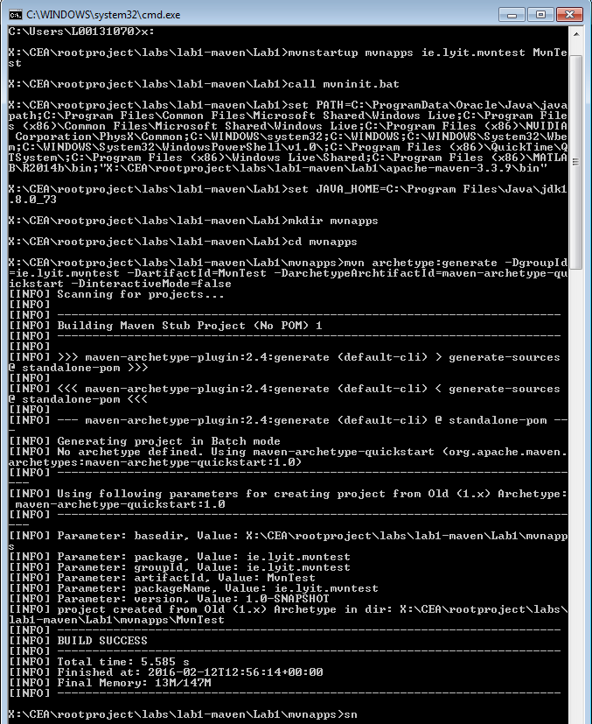  
mvnsetup.bat:  
call mvninit.bat

mkdir %1

cd %1

mvn archetype:generate -DgroupId=%2 -DartifactId=%3 -DarchetypeArchtifactId=maven-archetype-quickstart -DinteractiveMode=false

cd %3

mvn package

# Conclusions

The installation of maven did not present any problems following the instructions of the lab description.

A batch file was created to set the environment variables needed to run maven.

The setup of a new project did not present any problems using the instruction in the lab description.

A batch file was created to automate the setup of a new project using command line parameters for variable parameters of the setup and compile the generated project for verification that the generated project does compile and run the tests successfully.

Maven is one of several the build tools. Ant would be another one. Mavens advantage is the inclusion of a repository of libraries which are scanned and downloaded as maven progresses through the build process.

Build tools in general ease the burden of knowing every step of the build process and save a lot of time. If build on another system maven can be setup to download the required source from a revision control system and download all the dependencies from its repository.

# References & Bibliography

1. 1. Sawiyati, Basic Centos Setup Before Building a Working Server, 2013, Available at: http://www.servermom.org/basic-centos-setup-before-building-a-working-server/414/ , Accessed: 2nd May 2015.

  
2. 1. Anon, Install CentOS 6, 2014, Available at: http://www.server-world.info/en/note?os=CentOS_6&p=install , Accessed: 22nd September 2014.

  
3. 1. Galusonka, C., Getting Help/ Documentation, 2014, Available at: http://wiki.centos.org/Documentation , Accessed: 22nd September 2014.

  
4. 1. Editor: VMWARE, “Getting Started with VMware Workstation 10”, Available at: http://www.google.ie/url?sa=t&rct=j&q=&esrc=s&source=web&cd=1&ved=0CB8QFjAA&url=http%3A%2F%2Fwww.vmware.com%2Fpdf%2Fdesktop%2Fws10-getting-started.pdf&ei=z-UfVK7HIaH-ygPt0oLQDA&usg=AFQjCNG5GrEY3pV0M67q5qsTAe5zG2pV1Q&sig2=CKXWiGZHRVnS63VrJGN9PQ&bvm=bv.75775273,d.bGQ&cad=rja, Available on : 22nd September 2014.

  
5. 1. Editor: VMWARE, “Using VMware Workstation for VMware Workstation 10”, Available at: http://www.google.ie/url?sa=t&rct=j&q=&esrc=s&source=web&cd=2&cad=rja&uact=8&ved=0CCcQFjAB&url=http%3A%2F%2Fwww.vmware.com%2Fpdf%2Fdesktop%2Fws1001-using.pdf&ei=BecfVJbiDKPnygPVjoKICg&usg=AFQjCNHAOXKiSNDqdrM87Ij3Hhr5BtT8cQ&sig2=5HdIcuFVIK4vLXnjGaSCOQ&bvm=bv.75775273,d.bGQ ,Accessed: 22nd September 2014.

  
6. 1. Anon, VMWare Workstation 10 Documentation Centre, Available at: http://pubs.vmware.com/workstation-10/index.jsp?topic=%2Fcom.vmware.ws.using.doc%2FGUID-012378D8-A995-4B78-AAD3-5A4223C4093E.html, Accessed: 22nd June 2015.

  
7. Ellis, S., Updating your system with Yum, 2005, Available at: <https://www.centos.org/docs/5/html/yum/sn-updating-your-system.html>, Accessed: 22nd September 2014.

   Editor: VMWARE, Types of supported Virtual Disks on ESXi/ESX hosts (1022242), 2014, Available at: <http://kb.vmware.com/selfservice/microsites/search.do?language=en_US&cmd=displayKC&externalId=1022242>, Accessed: 22nd June 2015.